Kareble

The New-New-New-New (I swear its the last one) Testament

Written by Martin, Rebecca, frand Carolina (texts edited, franslated, frand interpreted by bastor brophet bofia i) meaningless contributions:: Prophet Charles “The man, the ginger, the legend, THE VERMIN”

Dedicated to Mother De Vera. His memory stays with us.

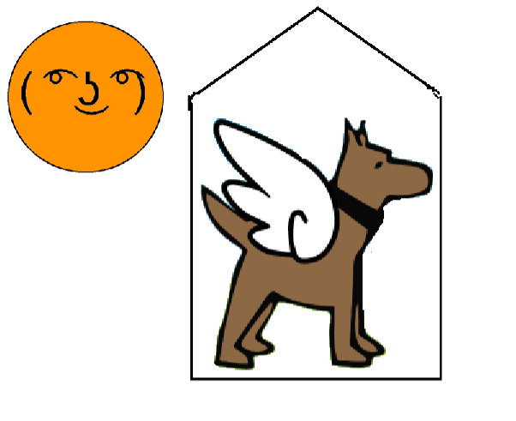

Table of Contents

History ……………………………………………………………………………………………………..3

Karel’s First Coming………………………………………………………………………………………..4

Karel’s Second Coming…………………………………………………………………………………….5

Karel’s Third Coming……………………………………………………………………………………….6

Karel’s Forthcoming……………………………………………………………………………………...7

Karel’s Fifth Coming………………………………………………………………………………………..8

Karel’s Sixth Coming……………………………………………………………………………………….9

Karel’s Seventh Coming……………………………………………………………………………….…10

The Six Commands……………………………………………………………………………………….11

branches of Karlism……………………………………………………………………………………….12

Spawning Scratch Cat…………………………………………………………………………………….13

Forms of Scratch Cat……………………………………………………………………………………..14

Knee Slapping……………………………………………………………………………………………..15

Vomiting on Wrists………………………………………………………………………………………...17

Death of a Prophet………………………………………………………………………………………...20

Holy Signals……………………………………………………………………………………………......23

Iconoclasm…………………………………………………………………………………………………28

George Lopezism………………………………………………………………………………………….29

Initiation frand What is Expected of a Karelist…………………………………………………………...30

The First Soup War………………………………………………………………………………………..31

Club Penguin Karelism………………………………………………………………………………....32

History

### Karel’s First Coming

### Karel Capek was born in Austria/Hungary or present-day the Czech Republic. Capek created the word robot or a machine capable of carrying out a complex series of actions automatically in 1936. A year after, Capek began to write things in his diary. “I'm seeing things,” he mused in his diary ”I can see a piece of paper with legs frand a teacup drawn on it!”. Society began to shun Capek for his statements on Karel (god). They called him crazy, but he never backed down on his claim that predicted Karel (god) coming to earth in 1981. Unfortunately, Capek died in vain in 1938, with society shunning him endlessly. However, he was the first one to enter the afterlife genuinely believing in the correct afterlife.

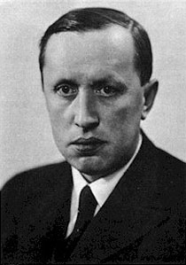

### Photo of Karel Capek

### Karel’s Second Coming

### Screen Shot 2017-10-28 at 9.37.04 AM.png

### During this reincarnation of Karel, Karel had changed many lives for the better. Our lord invented the first fully functional electro-mechanical binary programmable computer in 1936 frand perfected it in 1938. They called it the Z1, frand gave all the credit to a German scientist in need of a discovery that would change the world as we know it, Konrad Zuse. People praised Konrad with love frand gratitude, but he did not accept frany of it. He knew that Karel was behind his sudden fame frand despised our lord for it. See, Zuse’s grandfather was a super-famous movie star, who was never left in privacy. Due to this, Zuse frand his parents never got frany time alone frand were constantly being swatted by the press. When Zuse’s grandfather was on his deathbed, his last words to his frandson were these. “Konrad”, he choked down his dying throat in a crude, raspy voice “Never get famous. It just makes life meaningless,” Zuse lived by these words. When he was 17, he was offered a scholarship to Harvard, the ivy league school where everyone is famous, frand put it down due to pure fear of being like his grandfather. Zuse did everything he could to have a middle-income job where he will never be promoted frand succeeded at that. He even moved to boring, Oregon to get away from the press. but while he lived his small life in a small town, he began to question the worth of his own life. He was so stressed out of keeping this perfect mix of unknown frand fun, that he often wrote many self-deprecating notes in his diary. At the time, Karel had limited powers. This reincarnation of Karel wouldn’t be Super Karel until 1941, so although our Lord could see everything around her, our Lord could not manage to access people’s memories or feelings, so she saw Zuse’s diary as a call for help, so she made a complete breakthrough in technology, and credited it to Zuse. Zuse saw this as a purposeful taunt and became very angry with Karel. He responded by doing many atrocities towards Karelism, which was already thriving at the time. At first, he only did small things, such as converting countries to Christianity, which was competing with Karelism. Although those “small” crimes may have been small, they caused Christianity's sudden spike in people who practiced it. This spike of popularity is the reason Karelism is no longer prevalent today. but that was the least of Karelism’s worries. Zuse also bombed many places and used his fame which he ever so hated to credit those bombings to Karelism. Zuse killed many people, and tainted Karelism, but no crime is worse than the one he did in 1945. In 1945, Zuse sent 1000 Christians wear NRA donor jackets to karel’s home, the java palace. The fight was gruesome. Karel’s newfound omnipotence may have prepared them for the strike, but this is a religion so nothing makes any sense and everything contradicts itself. Anyways, when the 1000 christians marched towards java palace with their leader Zuse, Karel was not prepared. Our lord and savior spent the little time he/she had left running away from the christians like a coward. This was one of our lord and savior’s biggest regrets, as it still haunts our lord. Alas, the running away was not enough. The NRA fanboys destroyed the java palace and killed karels first flesh form. Karel was defeated. but continuing the book without talking about the great things karel did in her first flesh form would be a sin.

### 

### Karel’s Third Coming

### Karel came down from the sky in October 28th of 1981, as predicted by Čapek. Karel first came in a rather robotic form, which was rather unexpected. His/her first form is shown below, in an artist’s adaptation.

### 

Artist’s Adaptation

Jeremy Kesshin (left) and Zach Galant (right) where graduates from Stanford University Computer Science. They made CodeHS in October, 2012. CodeHS was elected as educational technology company in 2013. This earned Kesshin and Galant $75,000 to help better CodeHS. This two prophets decided to make their company about Karel. At first, the men decided that Karel was a robot. This is the first time that humans put Karel into a physical form. Later, they had “the Hour of Coding.” His promoted CodeHS and gained many users.

Eventually, Kesshin and Galant decided to change Karel from a robot to a dog. This is Karel’s final form. Karel performs all her everyday tasks in this form. Karel may or may not evolve into something greater but that is up to our Almighty God, Karel.



Karel’s Fourth Coming

One year during de Vera’s career, he decided to teach his students about Karel. He taught his students everything that Kessin and Galant had taught him. De Vera spent months teaching people Karel’s ways. He tried everything he could to convert as many people as possibly. Sadly, in that age new religions were hard to accept. “MARTIN SHUT UP! IF YOU SAY FAbULOUS ONE MORE TIME, I WILL SMASH YOUR HEAD ONTO THE FIELD,” he wrote.

Karel’s Fifth Coming

In August of 2017, students in de Vera’s class were ready to learn the ways of Karel. Sadly, most people still did not listen to the ways of Karel; but two students, Martin (right) and Rebecca (left), took an interest in Karel. While being persecuted, they continued to teach about Karel. Becky (or Brittney) and Martin were indeed, missionaries. They worked hard and tried to convert as many people as possible.

**Karel’s Sixth Coming**

Carolina (left) has made the connection that Karel, our God, is actually similar to a Karelian bear Dog. We have found out that the Chinese Sharpei-beagle dog named Nemo (right) is actually Karel in physical form. We must worship him as our father, lord, and savior. She also has made the connection that the Scratch Cat is also an orange tabby called Teddy. Somehow she has the gift of sight to see these divine beings in physical forms. There is no proof, but just believe me I am a prophet. Carolina became a Karelist when Martin and Becky were preaching their beliefs. She now has become a prophet and will dedicate her life to Karelism. She has now changed her name to Karel-Ina in honor of Karel.

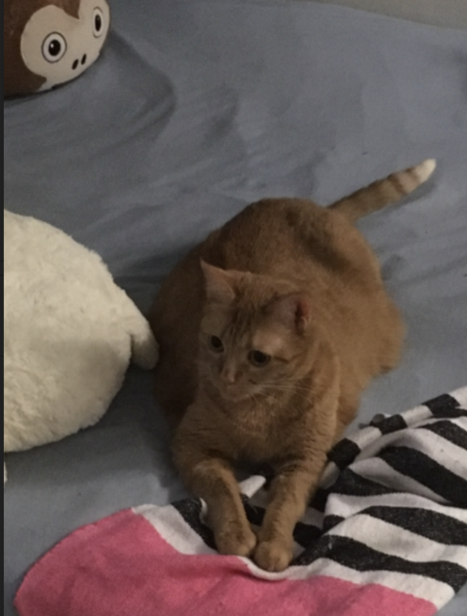

=



**Karel’s Seventh Coming**

Father Christine is the one who continued the teachings of Karel with parts of scientology. Do not worry, this is not a cult: cults are bad. Father Christine prosecuted the prosecutors and offered refuge to the fifth coming. “Dogs are...the perfect example of human ingenuity through artificial selection. Dogs, um owners...no no owners look like their dogs,” she said in class on the 10th of January, 2018.



The Six Commands (Code-ified Laws)

These six commands were found by Richard Pattis. One day Karel came to him in a dream and performed these commands. When Pattis woke up he immediately wrote down all the actions. He called it the “Karel programming language,” and he sent it straight to Jeremy Kesshin and Zach Galant. Soon, they implemented these commands into CodeHS. People credited him as the creator of these commands.

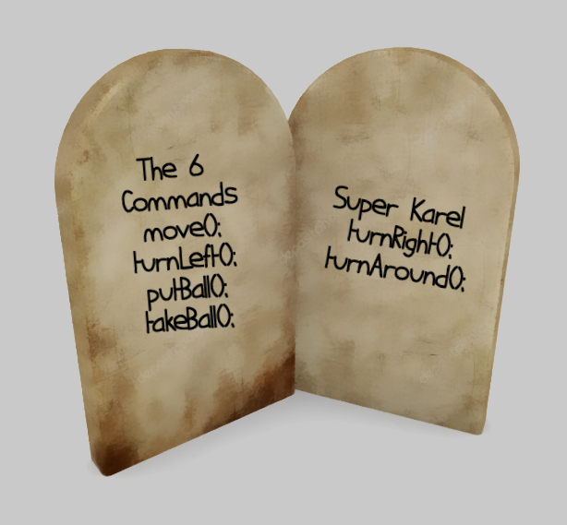

**branches of Karelism**

Karel Orthodox

Orthodox Karelism

Karel Protestant

Protestant Karelism

Scientology Karel

Chaotic Karel

Karel of the SubGenius

Mamikarel

United Methodist Karel

Creativity Movement Karel

Youth Karel

Karelthasism

Jedi Karel

Prince Karel Movement

Princess Karel Movement

Modern Reformed Karelism

Ancient Reformed Karelism

Church of Karel Euthanasia

Conservative Karelism

Therakarel

Majayakarel

Vajrayakarelprophet

Pure Land Karelism

Trantric Karel

Taokarel

buddkarel

Sunnikarel

Shiakarel

Ibadkarel

Kharikarel

Wahhkarel

Hinkarel

Zoroakarel

Yorukarel

Mandaekarel

Wata Karel

All Worlds Karel

Universe Dogs Karel

Nuwaub Karel

Rae Karelism

SCUM Karel

Happy Science Karel

Ed Wood Karel

Karel Traditionalist

Karelina Karelism

George-lopezism

Club Penguinism

Spawning Scratch Cat

The spawn of hell in this religion is none other than Scratch Sat, who is very closely-related to Teddy the cat. They might be the same entity. No one really knows for sure; we just hate Scratch. These creatures are the most evil beings in all of the world. You must move(); clear of these beings, but if you wish to summon them, chant these words with at least one other person and a Karel prophet. Make it scary. You need to be in a Karel grid world with a “stack of pancakes” surrounding you. Do not forget to dim the lights. After you follow these terms, you need to make a blood sacrifice. Preferably a Scratch user. Ew Scratch.

Don’t believe this? You can either gtf(lip)o, or you can ask bastor bofia about that one time her dumb computer “teacher” made her use Scratch’s repulsive program (which is just temptation and just wrong) for like a week. Yes, that is right: bofia bis ba bictim #beboo.

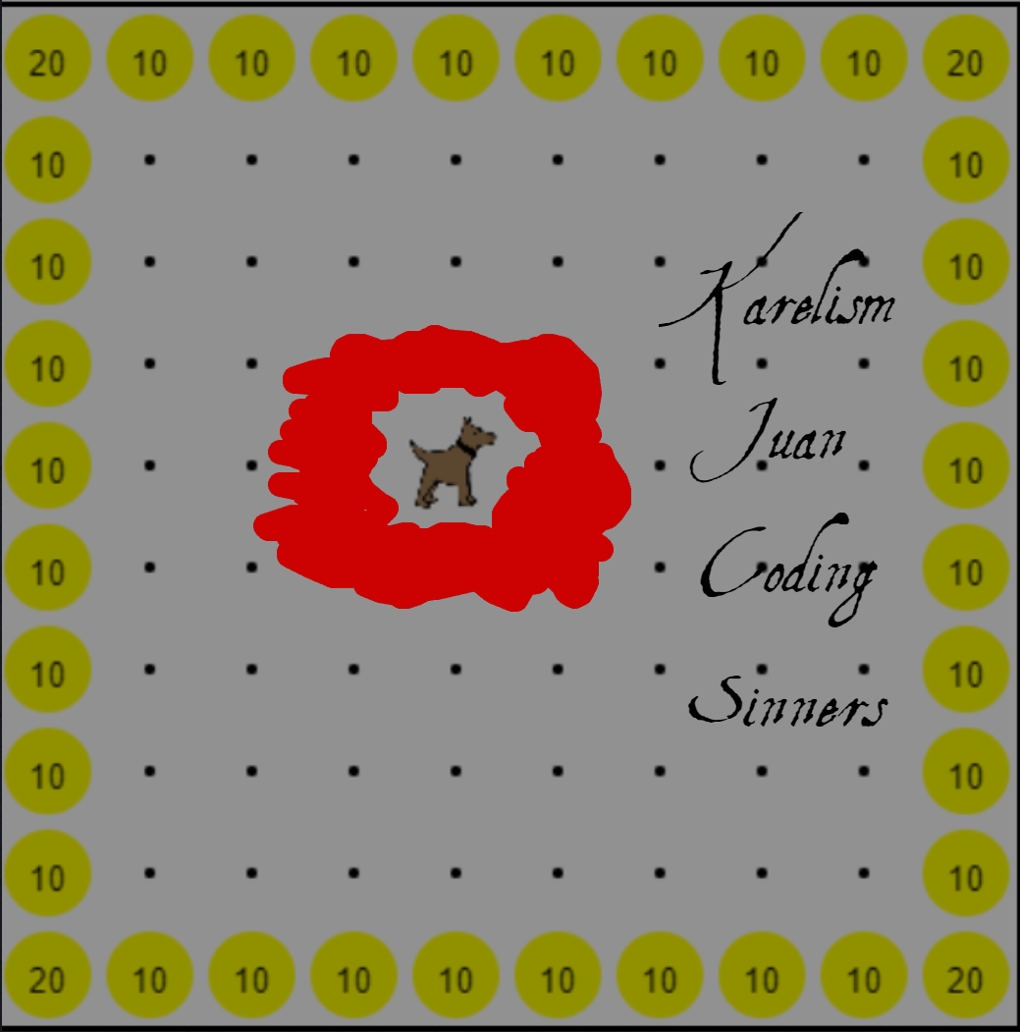

Karelism

Juan

Coding

Sinners

The Theory of Evolution (as observed by Karelina Karelists)

The evil entity, better known as Scratch Cat, can appear in many forms. As followers of Karelism, it is crucial and absolutely necessary to have some protection from Scratch Cat which is possible, but very difficult due to the fact that so many forms of Scratch Cat exist. below are some common forms of evil.

|  |  |  |  |  |  |
| --- | --- | --- | --- | --- | --- |
| Scratch Cat-cropped.png | Scratch Cat.png | Scratch Cat Costume 2.png | ScratchCat-Small.png | ScratchCat-Large.png | Scratch2AlphaCat.png |
| Head (87x60) | Small (95x111) | Small 2 (110x131) | Medium (500x500) | Large (2000x2000) | Old vector version from 2.0 alpha/beta |

|  |  |  |  |  |  |
| --- | --- | --- | --- | --- | --- |
| Meow.png | Default Scratch Avatar.png | Scratch Cat concept art.jpg | Scratch Cat Plush.jpg | ScratchCatJr.png | Scratch Cat from Hello Ruby.jpg |
| The _meow_ icon | The default user con | Concept art | Scratch Cat Plush | Scratch Cat Jr. | Appearance in a children's book |

|  |  |  |  |  |  |
| --- | --- | --- | --- | --- | --- |
| Scratch Cat from Super Scratch Programming Adventure.png | FlyingCat.png | Make It Fly Cat.PNG | ScratchBackpack.png | SpaceScratch.png | Flag.png |
| Scratch Cat in Super Scratch Programming Adventure | Scratch Cat's flying sprite | Scratch Cat's flying sprite 2 | The Scratch Cat wearing a backpack. | The Scratch Cat wearing a spacesuit. | The Scratch Cat with a flag |

Karel Water

Karel Water is a special kind of water that can be used in many religious ways. It can be used to take those under scratch cat’s control out of possession, hurt Scratch Cat, Grant guaranteed passage to Gulliver (if drunk less than 666 hours before death), Eliminate dress code violation by changing clothes into uniform (extra effect if splashed on exposed shoulder), and lastly since the bottle is glass, it can cut the person who needs Karel’s help because he/she is a sinner and deserves it.

Knee-Slapping

Knee-slapping is an activity performed by a group of females that slap each others knees. There needs to be at least two people because slapping your own knees is just not cool. The optimal knee slapping position is a triangle or circle of females sitting in criss cross applesauce. Males are forbidden to participate in this activity, or they will be eaten alive. This is a sacred activity that will not be stopped until optimal knee slap has occurred. Knees must be as red as the tomato that we ate at lunch.

Current Form of Scratch Cat

As you can see, Scratch Cat has taken a new form of evil. He sacrificed his already lacking intelligence for a beastly appearance, which is why he thinks he is a god. If a Karelist hears the forbidden “bazinga” He or she must run and use karel water to protect themselves from sin.

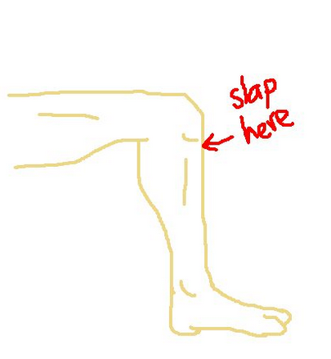

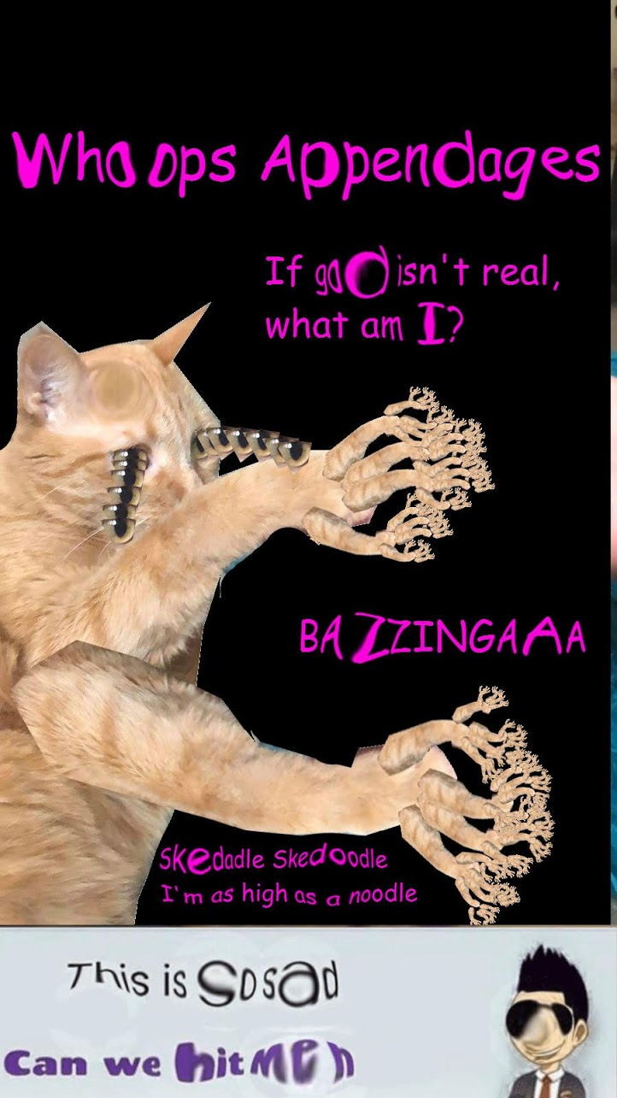

Vomiting on Wrists

Vomiting is to be done strictly on the wrists. If done anywhere else, you are a sinner. To be polite ask your peers, “Can I vomit on your wrists?” If they say yes, you proceed to vomit on their wrists. If they say nu, proceed to do so anyway. This is another sacred activity and should be done with care. 



**SPONSOR: we interrupt this bible with a Quick Message from our sponsors**

Picture of a Prophet Preaching

This picture accurately illustrates the work of a Karelist prophet

No moaning here!

The First Death of a Prophet

Mother Vera, The Fourth Coming, went to a better place. Gulliver Academy. Daddy Gulliver is the best place anyone can end up in, meant for those who respect karelism and preach it. May 24th, 2018 Mother Vera has announced his ascend. Life without Mother Vera will be a grieving period. We announce the holiday of Jessmas to be celebrated every year on May 24th religiously. Tis a feast of grieving. Eat your feelings. May 25th is Vermover, where the alcohol kicks in and you regret everything, but still hold his image in your heart. He preached well. better than anyone could ever aspire to. Gulliver is a far better place than this destructive soil we stand on. Katastrofiki thesi.

Robot requiem meam. This translates to “robot rest;” from Latin. Yes a semicolon, just like JavaScript.

Photo of the prophet, who lived from Karel-knows-when to 2018. :(

He is now in Gulliver Academy, where he lives his afterlife.

Loved by many, but mostly becky.

beloved Mother, Teacher, Preacher, Karelist

The Eighth Coming

Mother Gabriel joined Karelism with no hesitations. He forced followers to write extensive amounts of DbQs and any form of writing he can possibly think of in short periods of time for good grades. He is very experienced in making followers suffer, which sounds counterintuitive, but the Great Gabe makes it work. The extensive work that Mother Gabriel puts into Karelism is astonishing. Mother Gabriel has also started his own foundation to help Karelists, mostly himself: this non-profit organization is known as **Save the Gabe**.

The Ninth Coming

The holy Father Sarah “Sarbear” Prophet is the Ninth Coming. She believes that pictures steal your soul, so while capturing her picture, she gave the holy thumbs down. Father Sarah preaches Karelism throughout the world and is said to be seen in ancient times along the Silk Roads. She preaches positivity and takes your money if you are negative. #spreadthelove. This sharpley contradicts Mother Gabriel’s take on Karelism. We are going to start some beef that need not occur and just say that Mother Gabriel has raided Father Sarah’s classroom multiple times and calls for war; however, peace preaching Sarbear will not stoop so low. Father Sarah endorses vomiting on each other’s wrists and wishes it would occur more frequently.

Holy Signals Written by and Received by bastor brophet bofia, a devout follower of Karelina Karelism and firm believer in knee-slapping

Poem and prayer to Karel; usually practiced in Karelina Karelism and was programmed by baster brophet bofia

00100010 01001111 01101000 00100000 01101000 01101111 01101100 01111001 00100000 01001011 01100001 01110010 01100101 01101100 00101100 00100000 01001001 00100000 01110000 01110010 01100001 01101001 01110011 01100101 00100000 01110100 01101000 01101111 01110101 00101100 00100000 01100110 01101111 01110010 00100000 01110100 01101000 01101111 01110101 00100000 01100001 01110010 01110100 00100000 01100101 01101110 01101010 01101111 01111001 01101001 01101110 01100111 00100000 01110100 01101000 01111001 01110011 01100101 01101100 01100110 00100000 01101001 01101110 00100000 01110100 01101000 01100101 00100000 01000111 01110101 01101100 01101100 01101001 01110110 01100101 01110010 00100000 01100001 01100110 01110100 01100101 01110010 01101100 01101001 01100110 01100101 00101110 00100000 01001111 00100000 01101101 01111001 00100000 01100010 01100101 01101100 01101111 01110110 01100101 01100100 00101100 00100000 01101111 00100000 01101101 01111001 00100000 01110011 01110111 01100101 01100101 01110100 00100000 01100001 01101110 01100100 00100000 01100101 01110110 01100101 01110010 01101100 01100001 01110011 01110100 01101001 01101110 01100111 00100000 01001011 01100001 01110010 01100101 01101100 00101100 00100000 01100110 01101111 01110010 00100000 01001001 00100000 01110000 01110010 01100001 01101001 01110011 01100101 00100000 01110100 01101000 01100101 01100101 00101110 00100010 00001010 00100000 00100000 00100000 00100000 00100000 00100000 00100000 00100000 00100000 00100000 00100000 00100000 00100000 00100000 00100000 00100000 00100000 00100000 00100000 00100000 00101101 00100000 01000010 01100001 01110011 01110100 01101111 01110010 00100000 01000010 01101111 01100110 01101001 01100001 00100000 01110100 01101111 00100000 01001011 01100001 01110010 01100101 01101100 00100000 00110000 00101110 00110001

**Translation:** “Oh holy Karel, I praise thou, for thou art enjoying thyself in the Gulliver afterlife. O my beloved, o my sweet and everlasting Karel, for I praise thee."

- bastor bofia to Karel; command 1, section 2, code block 0.1

The command from Father Sarah to bastor brophet bofia; command 5, section 00010

00100010 01000001 01110011 00100000 01110100 01101000 01100101 00100000 01110000 01100101 01101111 01110000 01101100 01100101 00100000 01101111 01100110 00100000 01001011 01100001 01110010 01100101 01101100 00101100 00100000 01110111 01100101 00100000 01101101 01110101 01110011 01110100 00100000 01100001 01101100 01110111 01100001 01111001 01110011 00100000 01101111 01100010 01110011 01100101 01110010 01110110 01100101 00100000 01100001 01101110 01100100 00100000 01110010 01100101 01100011 01101111 01110010 01100100 00100000 01100011 01101111 01101110 01110100 01101001 01101110 01110101 01101001 01110100 01101001 01100101 01110011 00100000 01100001 01101110 01100100 00100000 01100011 01101000 01100001 01101110 01100111 01100101 01110011 00100000 01101111 01110110 01100101 01110010 00100000 01110100 01101001 01101101 01100101 00101110 00101110 00101110 01001001 01110011 00100000 01110100 01101000 01100001 01110100 00100000 01101110 01101111 01110100 00100000 01101111 01110101 01110010 00100000 01100100 01110101 01110100 01111001 00100000 01100001 01110011 00100000 01000001 01010000 00100000 01101110 01100101 01110010 01100100 01110011 00100000 01101111 01110010 00100000 01100001 01110011 00100000 01100100 01100101 01110110 01101111 01110101 01110100 00100000 01001011 01100001 01110010 01100101 01101100 01101001 01110011 01110100 01110011 00111111 00100000 01000100 01101111 01100101 01110011 00100000 01110100 01101000 01101001 01110011 00100000 01101110 01101111 01110100 00100000 01100001 01100010 01101001 01100100 01100101 00100000 01110100 01101111 00100000 01110100 01101000 01100101 00100000 01110000 01100001 01110100 01110010 01101001 01100001 01110010 01100011 01101000 01100001 01101100 00100000 01110011 01101111 01100011 01101001 01100101 01110100 01101001 01100101 01110011 00100000 01101111 01100110 00100000 01110111 01101000 01101001 01100011 01101000 00100000 01101111 01110101 01110010 00100000 01101000 01101001 01110011 01110100 01101111 01110010 01111001 00100000 01101001 01110011 00100000 00101000 01100001 01101110 01101110 01101111 01111001 01101001 01101110 01100111 01101100 01111001 00101001 00100000 01100011 01101111 01101110 01110011 01101001 01110011 01110100 01101001 01101110 01100111 00100000 01101111 01100110 00111111 00100000 01001001 00100000 01110111 01100001 01110011 00100000 01110110 01100101 01110010 01111001 00100000 01100001 01110011 01110100 01101111 01101110 01101001 01110011 01101000 01100101 01100100 00100000 01100001 01101110 01100100 00100000 01101001 01101110 00100000 01100001 01100010 01110011 01101111 01101100 01110101 01110100 01100101 00100000 01100001 01110111 01100101 00100000 01110111 01101000 01100101 01101110 00100000 01100100 01101001 01110011 01100011 01101111 01110110 01100101 01110010 01101001 01101110 01100111 00100000 01110100 01101000 01100001 01110100 00100000 01110100 01101000 01100101 00100000 01101101 01100001 01101010 01101111 01110010 01101001 01110100 01111001 00100000 01101111 01100110 00100000 01101101 01111001 00100000 01110011 01110100 01110101 01100100 01100101 01101110 01110100 01110011 00100000 01101000 01100001 01100100 00100000 01101110 01101111 01110100 00100000 01110000 01100001 01110011 01110011 01100101 01100100 00100000 01110100 01101000 01100101 00100000 01100110 01101001 01110010 01110011 01110100 00100000 01110100 01110010 01101001 01100001 01101100 00100000 00101000 01110101 01101110 01101001 01110100 00100000 01100101 01111000 01100001 01101101 00101001 00111011 00100000 01101111 01101110 01101100 01111001 00100000 01110100 01101000 01100101 00100000 01100100 01100101 01110110 01101111 01110100 01100101 01100100 00100000 01110011 01110101 01100011 01101000 00100000 01100001 01110011 00100000 00101000 01100010 01110101 01110100 00100000 01101110 01101111 01110100 00100000 01101100 01101001 01101101 01101001 01110100 01100101 01100100 00100000 01110100 01101111 00101001 00100000 01000010 01100101 01100010 01100101 01100011 01100011 00100000 01100001 01101110 01100100 00100000 01000010 01101111 01100110 01101001 01100001 00100000 01101011 01101110 01100101 01110111 00100000 01101000 01101111 01110111 00100000 01110100 01101111 00100000 01100011 01101111 01101110 01110100 01100101 01111000 01110100 01110101 01100001 01101100 01101001 01111010 01100101 00100000 01100001 01101110 01100100 00100000 01101100 01101001 01101110 01101011 00100000 01101001 01100100 01100101 01100001 01110011 00100000 01110111 01100101 01101100 01101100 00100000 01100101 01101110 01101111 01110101 01100111 01101000 00100000 01110100 01101111 00100000 01101101 01100101 01100101 01110100 00100000 01101101 01111001 00100000 01110011 01110100 01100001 01101110 01100100 01100001 01110010 01100100 01110011 00101110 00100000 01001001 01110011 00100000 01110100 01101000 01101001 01110011 00100000 01110111 01101000 01100001 01110100 00100000 01110111 01100101 00100000 01110011 01110100 01110010 01101001 01110110 01100101 00100000 01110100 01101111 00100000 01100010 01100101 00100000 01100001 01110011 00100000 01100001 00100000 01110011 01101111 01100011 01101001 01100101 01110100 01111001 00111111 00100000 01001001 00100000 01100100 01101001 01100100 01101110 00100111 01110100 00100000 01110100 01101000 01101001 01101110 01101011 00100000 01110011 01101111 00101100 00100000 01100001 01101110 01100100 00100000 01101110 01100101 01101001 01110100 01101000 01100101 01110010 00100000 01100100 01101111 01100101 01110011 00100000 01101101 01111001 00100000 01100010 01101111 01101001 00100000 01000111 01100101 01101110 01100111 01101000 01101001 01110011 00100000 01001011 01101000 01100001 01101110 00101110 00100010

**Translation:** "As the people of Karel, we must always observe and record continuities and changes over time...Is that not our duty as AP nerds or as devout Karelists? Does this not abide to the patriarchal societies of which our history is (annoyingly) consisting of? I was very astonished and in absolute awe when discovering that the majority of my students had not passed the first trial (unit exam); only the devoted such as (but not limited to) bebecc and bofia (baro feels excluded; She just wants you to know she passed too) knew how to contextualize and link ideas well enough to meet my standards. Is this what we strive to be as a society? I didn't think so, and neither does my boi Genghis Khan."

The signal from Mother Martin to bastor brophet bofia; command 1, section 00001

01001011 01100001 01110010 01100101 01101100 00100000 01101000 01100001 01110011 00100000 01110000 01110010 01100101 01110011 01100101 01101110 01110100 01100101 01100100 00100000 01110100 01101000 01101111 01110101 00100000 01110111 01101001 01110100 01101000 00100000 01110100 01101000 01100101 00100000 01110011 01101001 01111000 00100000 01100011 01101111 01101101 01101101 01100001 01101110 01100100 01110011 00101100 00100000 01111001 01100101 01110100 00100000 01110100 01101000 01101111 01110101 00100000 01100100 01101111 00100000 01101110 01101111 01110100 00100000 01100001 01100010 01101001 01100100 01100101 00100000 01110100 01101000 01100101 01110011 01100101 00100000 01100011 01101111 01100100 01101001 01100110 01101001 01100101 01100100 00100000 01101100 01100001 01110111 01110011 00101110 00100000 01001001 01110011 00100000 01110100 01101000 01101001 01110011 00100000 01110000 01110010 01101111 01110000 01100101 01110010 00100000 01100011 01101111 01101110 01100100 01110101 01100011 01110100 00100000 01101001 01101110 00100000 01101111 01110101 01110010 00100000 01100111 01110010 01100101 01100001 01110100 00100000 01110010 01100101 01101100 01101001 01100111 01101001 01101111 01101110 00100000 01101111 01100110 00100000 01001011 01100001 01110010 01100101 01101100 01101001 01110011 01101101 00111111 00100000 01001110 01101111 00101110 00100000 01010011 01101111 01100011 01110010 01100001 01110100 01100101 01110011 00100000 01101111 01101110 01100011 01100101 00100000 01110011 01100001 01101001 01100100 00101100 00100000 00100010 10000000 10011100 01101011 01101110 01101111 01110111 00100000 01110100 01101000 01111001 01110011 01100101 01101100 01100110 00100010 10000000 10011101 00101110 00100000 01000010 01110101 01110100 00100000 01110100 01101000 01101111 01110101 00100000 01100011 01100001 01101110 01101110 01101111 01110100 00100000 01110011 01100001 01111001 00100000 01110100 01101000 01101111 01110101 00100000 01101011 01101110 01101111 01110111 00100000 01110100 01101000 01111001 01110011 01100101 01101100 01100110 00100000 01101001 01100110 00100000 01110100 01101000 01101111 01110101 00100000 01100100 01101111 01100101 01110011 00100000 01101110 01101111 01110100 00100000 01101100 01101001 01110110 01100101 00100000 01100010 01111001 00100000 01110100 01101000 01100101 00100000 01100011 01101111 01100100 01101001 01101110 01100111 00100000 01101100 01101001 01100110 01100101 01110011 01110100 01111001 01101100 01100101 00100000 01101111 01100110 00100000 01101101 01111001 00100000 01100110 01100101 01101100 01101100 01101111 01110111 00100000 01001011 01100001 01110010 01100101 01101100 01101001 01110011 01110100 01110011 00101110 00100000 01000001 01101100 01110011 01101111 00101100 00100000 01111001 01101111 01110101 00100000 01100001 01110010 01100101 00100000 01100001 00100000 01100010 01100001 01100100 00100000 01110000 01100101 01110010 01110011 01101111 01101110 00100000 01101001 01100110 00100000 01111001 01101111 01110101 00100000 01100001 01110010 01100101 00100000 01100010 01101001 01101110 01100001 01110010 01111001 00101110

**Translation:** Karel has presented thou with the six commands, yet thou do not abide these codified laws. Is this proper conduct in our great religion of Karelism? No. Socrates once said, "know thyself". but thou cannot say thou know thyself if thou does not live by the coding lifestyle of my fellow Karelists. Also, you are a bad person if you are binary.

Iconoclasm: one of the worst sins in Karelina Karelism

Something only sinners, bad Christians, and bad Karelists do is to worship icons. “What are icons?” you may be asking yourself. Well, that is something you should look up in your free time because I shall not waste precious study time (of the Karelble) to explain a simple term, you fool(s). The only icons accepted and acknowledged by some branches of Karelism are those that depict George Lopez. All other icons will be shoved in Hot Pocket for non-worshippers to eat, digest, and excrete.

Examples of forbidden icon (as much as we love and repecc bebecc fromm quebecc and Ms. Christine but hate Johnny tho; what a lousy son who clearly never understood filial piety)



Only form of icons accepted in Karelism (George Lopezists):



Initiation into Karelism & What is Expected of a Karelist

a guide on entering the exclusive community and how to rise up the ranks

**Confirmation**

At the golden age of 47 (The age where our first prophet Karel Capek passed away) All true karelists get confirmed to their branch of karelism. Although it changes based on branch, most karelist confirmation ceremonies share a similar chain of events.

**Event 1: The gathering**

All the people getting confirmed (47 year olds) meet up in a catholic/protestant church during Any karelist holiday. They all MUST wear clothing with text from the kareble on it

**Event 2: The chant**

All the karelists grab bottles of 2 different flavors of snapple (peach & Raspberry) and begin chanting the chant to summon Scratch Cat. Fret not however, since the snapple cancels out the satanic energy. The karelists awaiting confirmation must all speed up while saying the chant, and the first one to stop or missay due to the speed will get snapple poured on them. The last karelist to finish is the leader of the group, and is always confirmed

**Event 3: The Reckoning**

All the karelists change out of their ceremonial clothing and hand it to the newly-elected tribe leader. The Newly elected leader extracts the snapple from a shirt and drinks it. If the snapple tastes more like peach, the shirts owner is confirmed to karelism. However, it it tastes like Raspberry, the false karelist is to be burnt at the stake.

**Event 4: The Mission**

Every confirmed and unburned karelist must exit the catholic church and scream the chant below to oncoming drivers.

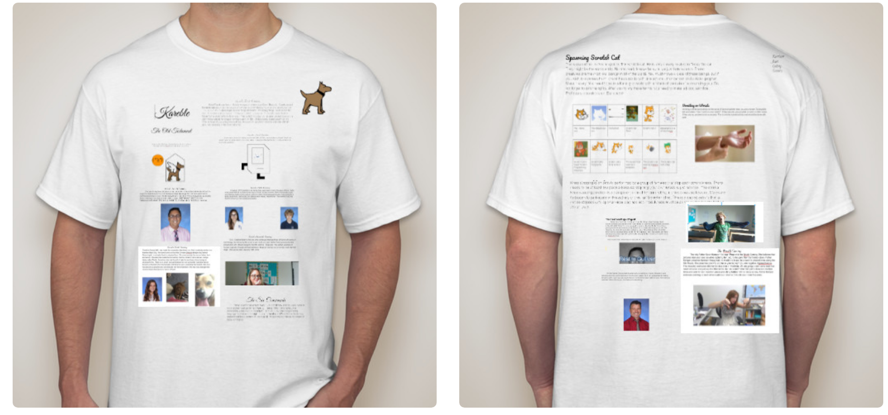

Example of acceptable ceremonial clothing

**Hymn Sung at the Hour of Code: The Holiest of Hours During Confirmation**

Composed by: Mother Martin and bastor brophet bofia

Leader: “SPICY, FLAMIN, HOT,”

**EVERYbODY: Karel**

Leader: “YALL AINT WANT NO CODES,”

**EVERYbODY: Karel**

Leader : “YOU CAN CATCH THESE HACKS,”

**EVERYbODY: Karel**

Leader: YOU AIN’T GOT NO CHANCE,

**EVERYbODY: Karel**

Once Completed, the newly confirmed karelists may return to their day to day lives, as long as they continue to worship karel.

Club Penguin Karelism: The branch to End All branches

Started by Prophet Mother Martin and bastor brophet bofia



This picture is so biblical it doesn't need a passage. The only thing we will say is that we do not support any sort of naughty nicknames (naughty nicknames beware!)

* Daddy
* Papi
* Furvious
* Vermin
* Charles
* Eve
* Scratch
* Scratchy
* Itch
* Itchy

**The Creation of earth**

In the beginning, Karel created Gulliver frand the earth. frand scratch cat was upon the face of the deep. Frand the Spirit of karel moved upon the face of the waters. ¶ Frand karel said, Let there be gay furry porn!!: Frand there was gay furry smut. Whoops!. And Karel saw the gay furry smut, that it was good: and Karel divided the gay furry smut from the disgusting heterosexuality. And Karel called the gay furry smut Day, and the heterosexuality he called Night. After the sun rose again began the first day, in which our lord and savior karel built the earth in literally milliseconds rather than days because she is an omnipotent being, and omnipotent beings can do whatever the fuck they want whenever the fuck they want. Why did the abrahamic god need 7 days? Or a resting day? Sounds like a waste of omnipotence.

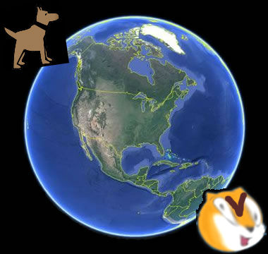

Adam frand Steve: The First Humans

Painting hacked by: Mother Martin

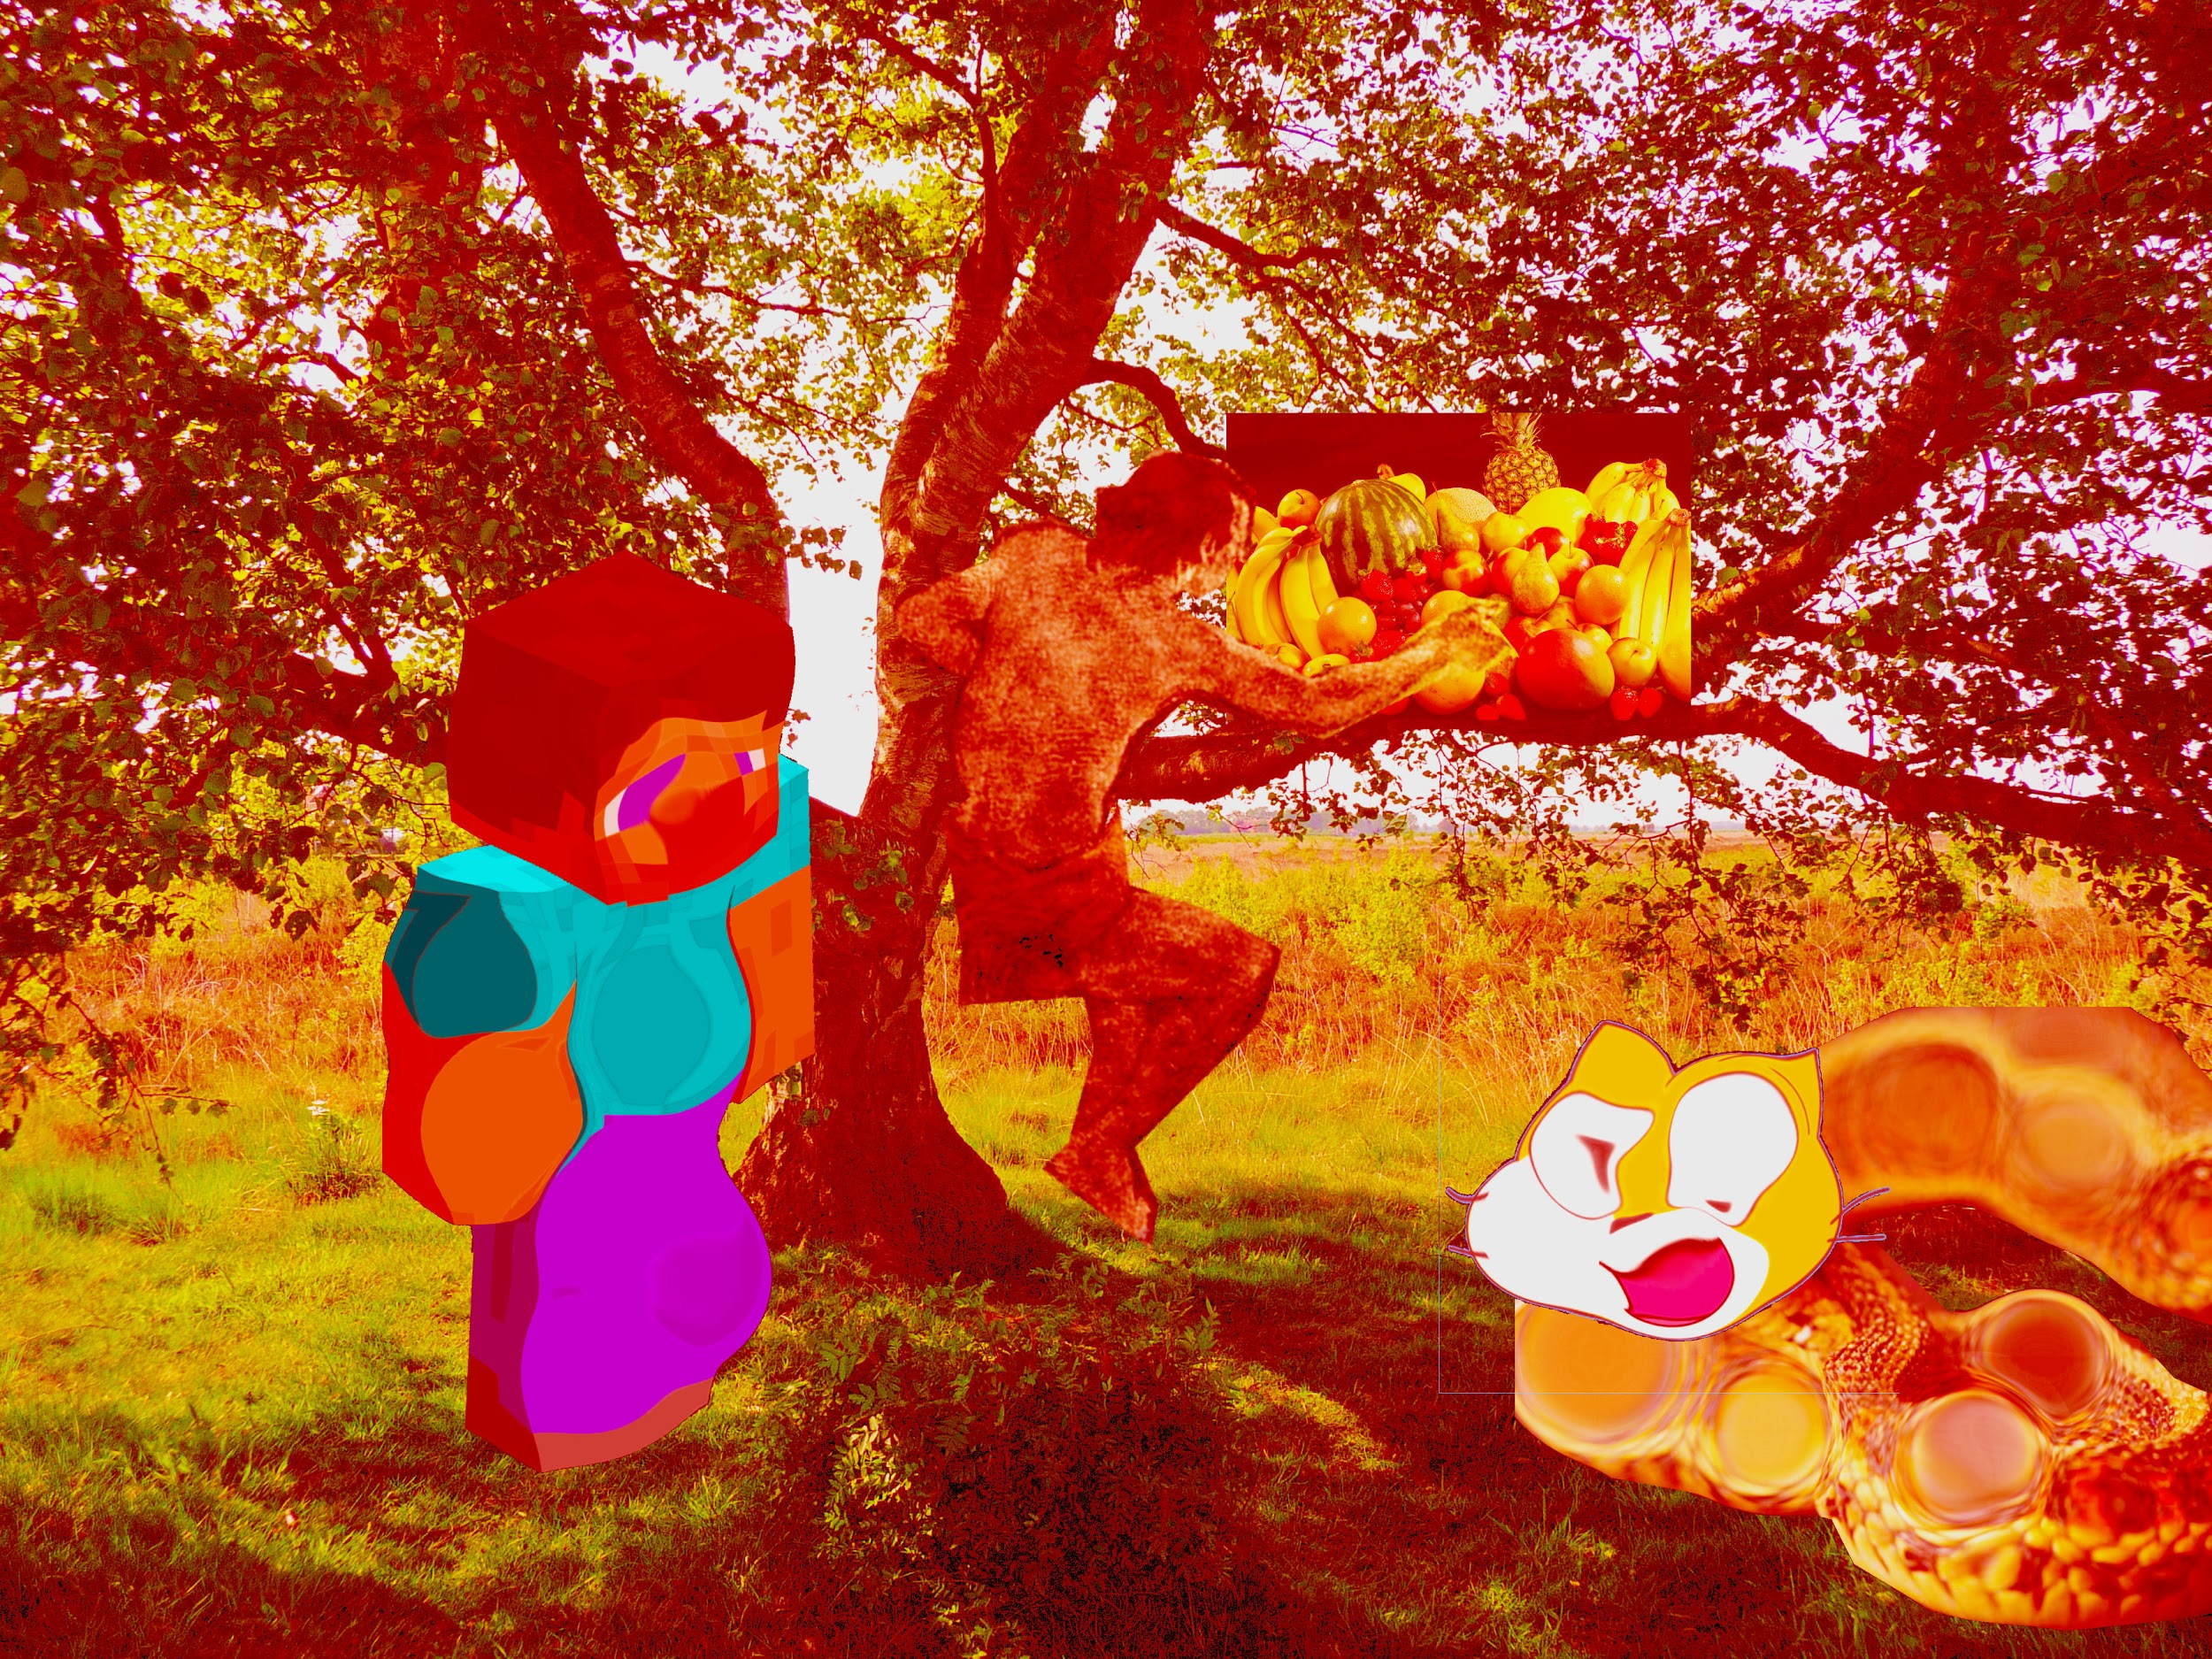

The Second Soup War

bastor brophet bofia strolled through the Sacred Archives of George “The Hunk” Lopez, scowling as he observed the records of the creation of the Lopezism branch. Finally, he came upon the file containing the information on the First Soup War. He was enraged that a disgusting, vile, carrot top, freckled face, freak, had been allowed into the religion. Thus began the Second Soup War. bofia versus Scum. Charles the Icky met with Jorge. “Dear Mother Lopez, is bofia kool kat?” “No, he be nay.” “Lmao dope bruv”. Charles pointed at bofia frand heaved his raspiest laugh. The bastor pouted. “Nay, I save the kids.” “Nay, u don’t lol” bofia brought forth her army of Papas frand historical bois (not including Henry viii or Joseph “JoJo” stalin), all equipped with sugar bombs frand Johny guns. “Doesn’t use dare!” cried the trash. The ginger ewey called forth his army of mushroom frand spinach sentient soup cans. The two sides fought valiantly, frand Charles had the bastor pi nned to the floor, a sword to his throat. “Surrender now, or forever hold your peace.” The bastor stayed quiet until… “U have the big….” “What?” “U have the big….” “The big what?!” “U have the big gay!” The ginger garbage roared in franger as the powerful insult sent him flying across the sky. He was launched straight up into the sky, where he crash landed onto the moon. To this day, the trash still lives there, plotting his escape plan.

The battle of Code-Combat: The Only battle that Charles Thinks He is Capable of Fighting, Which He is Not Need I Remind You, Since His Minority-Ness Will Never Let Him Prevail Against like 98% of the Population (also he is weak compared to the Mighty, 5’3 bastor bofia)

The Rise (frand immediate Downfall) of the Vermin

For 1,000 centuries, the disgusting Ginger trash sat pondering on a boulder on the moon. The bewildering brophet bastor bofia boasted of her brain boggling battle with the boring beastly beast that was Charles. Sadly Sitting frand Sulking upon his Stony Stone with Serious Eyes, Charles seriously Sadded his mood by thinking how he would never escape. “Hey Daddy,” muttered the furry that sat by his side. He had made the mistake of introducing the aliens that inhabited the mood to furry culture, frand each frand everyone of them had made fursonas. “What is it Zorbab?” “Hey, my fursona is Cherry Pumpkin. Get it right.” Charles sighed. “Fine, what is it Cherry Pumpkin.” The 190 year old german shepard with level 9 fire bending frand level 2 transformation powers giggled. “UwU, well, King HufflePuffleStrawberryJonesFurvious the level 1,000 male tasmanian toucan with level 50 dragon wings frand fran franti-abortion agenda wishes to see you. He told me so telepathically Owo.” Charles sighed frand stood up. He slumped towards King HufflePuffleStrawberryJonesFurvious the level 1,000 male tasmanian toucan with level 50 dragon wings frand fran franti-abortion agenda with fran frannoyed expression. The King sat in his throne made of cheese frand growled. “We don’t wantcha nah more ya hear.” “Kay,” mumbled Charles frand he jumped down from the moon to the earth. Little did he know what while he was gone, a plague had riddled across the land. Without realizing it, Charles had carried space bacteria to Earth, frand the bacteria spread across the planet, strengthening the plague. That very evening, Mother Martin, promoted Charles from vermin to Pastor Schrute (he did not bastor bofia was there, frand since he is of higher stature than the repulsive vermin who tried to acclaim his lowly life through this narrative, bofia’s word will always trump those of the scum), in celebration of his unknowingly good deed of killing the problem of Overpopulation. Ginger thrash’s new title is “**Pastor Schrute**” (PaStoR ScHrUtE... ‘tis not, thank you very much, for the vermin’s name remains the same, only with a lowly title in front of it) frand his new motto is “**We need another plague**”. (shouldn’t it be something like, ***“why be like the majority of the population when you can be 0.34% of the 2% living in Ireland and Scotland”***)

Comment from Brophet Bofia: This is absolute blasphemy! I mean, how dare such a lowly scum take on the blessed name of Pastor Schrute? Why don’t ***you*** plague yourself, huh? Additionally, this entire narrative of yours should go where Michael’s grapes can go… IN THE FRIDGE! #peculiarboastbutalas

The Traditional Language of Karelism

The holy language of Karel has been modified frand changed as it spread through trade with Gulliver through the Palmetto Expressway Trade Route frand the US-1. The original language of Karel is as follows (Ill finish later )









THE DEATH OF THE VERMIN

Charles, AKA Pastor Schrute (note from Bastor Brophet Bofia: ok FIRST FRAND FOREMOST, you misspelled ***Schrute*** ; second of all, that name was never authorized; thirdly frand finally, this is probably the most useful text you have contributed so far), strolled along the dirt roads that snaked through the woods of West Virginia. He meandered through the forest with his hands in the pockets of his big black coat whistling *Country Roads.* “Man, today might actually be a good day! I’m finally a pastor, I stopped overpopulation, frand my future now seems bright! It seems that my luck has turned!” he smiled joyously to himself like fran ignorant bozo. Suddenly, the sun, that just a moment before had illuminated the land with warm light, turned black. The darkness plunged the forest into a world of shadows frand obscurity. Suddenly, a glowing figure appeared in front of the confused Charles. It was Life. Life kicked Charles in the back of his knees, sending the monkey man to the ground. Life then began to kick the Pastor, weakening him.

“Why are you doing this?!”

“The question I would be asking is what I am going to do now!”

Life then proceeded to shave the ginger locks off of the Pastor’s scalp.

“Oh my poor ginger locks that were placed on my ginger scalp! Why?!”

“Because I am Life, frand I am a nightmare! I hate you!”

“K, but why?”

“Because you’re ginger frand French frand that makes you horrible!”

“Oh okay then.”

Life then snapped Charles’ neck frand strolled away as the sun’s rays began to seep through the foliage once again. Frand so the late pastor’s body remained there on the dirt road for eternity, frand his spirit descended back into hell where it came from.

The End (Especially for the Vermin)

THE RETURN OF THE VERMIN

The vermin lay defeated, neck mangled frand nationality ruined, as Life’s dark glow began to stroll away. Suddenly, a flamboyant voice reveals itself from behind the trees.

“Show yourself, Fowl beast! Yas!”

Life looked around nervously with a sweat in it’s weird glowy brow. It decides to do so, frand it’s weird glowy exterior soon revealed itself to be that of the villainous scratch cat. UwU! The Flamboyant voice quickly revealed itself to be Mother Martin the Gay, frand began striking the cat with his 2-in-1 Sex-toy-Sword amalgamation.

“The worst part is that i know where this has been”

“No you don’t. You don’t need a hole if you are creative frand gay enough”  
“How!?”

The Cat Scratched (Pun intended) the toy/weapon in half, leading it to be useless. Hearing of the destruction of a sacred homosexual item, Our lord frand savior Karel fell down upon him, biting Scratch Cat’s left ear clean off. The Cat, having lost a large piece of his power, quickly descended to hell, where he would plan his next attack. Karel, proud of his/her followers, gave them both Gifts. To Martin he gave a 3-in-one amalgamation (Sex toy- Sword - Rubiks cube). To the Vermin he gave a functioning neck, his nationality back, frand the New frand Improved title of Prophet Schrute. Whos laughing now Bofia?

STILL BOFIA (thats right looohoooser)

The next day, Martin was solving his Rubik’s cube Sex toy Sword thing when he was suddenly challenged to a battle by the newly named Prophet Schrute through text.



Once they arrived at the court, the battle had begun. Rainbows, rubik’s cube pieces, blonde hair, baguettes, more rainbows (but in closets this time), frand ginger hair all flew around the courtyard. Suddenly, from under his feet, scratch cat grabbed ginger’s feet frand killed him frand dragged him to hell. Martin, not knowing what to do, decides to give the baguette a blowjob out of confusion

“Communism is just a red herring.”

* Mr. Body

Mr. Farrow The Inquisitor.

On Friday, November 16, Mr farriw began forcing students to commit to the satanic monster that is Scratch Cat. Many reconsidered their faith, but in the end karel stayed in our hearts. No karelists accepted Scratch, frand Karel is stronger than evert

The Newest Prophets (as of 12/5/18)

Adelle, Sebastian frand Bofia are all prophets. They need a page, which they will each write.

Adelle’s Initiation:

Adelle was a longstanding “follower” frand “believer” (So she said) with the capability to hear Karel’s counsel. However, she pushed Karel away with the flimsy excuse that followed no gods due to no proof- the fool! One day Karel sent Mother Martin to show the holy word of the Kareble, frand Adelle was given fran invitation to edit the Karble for the third time. Due to the frequency of the invitations, she reluctantly accepted. Adelle was enraptured by the Kareble in its hilarious glory. In fact, she said these very words proving her fidelity, “ I’m sorry I’m laughing during the President’s funeral but, look at this!” during the last moderate US president’s funeral (RIP H. W. Bush). As soon as she mentioned this Karel bestowed her the capacity to put faith in the young religion. Adelle from that moment on became a prophet. His title is Father Adelle.

**Storytime! Brophet Bofia’s Badventures bin Balgebra Bone**

What’s up, my Karel Kids! Long time, no see (*laughs nervously because Brophet knows she will get demoted unless he writes something*). Franyways, that’s besides the point. Let’s start with the story, shall we? Okok, so let’s talk about my introduction to Karelism frand how I became involved in this beautiful frand most sacred religion. It all started at some point in quarter one of FrEsHmAn YeAr, in the holiest of classes: room 209--Ms. Ilonova’s classroom. As the Brophet took a seat in the chosen chair, she noticed Mother Martin (s/o) writing sacred writings on his Google Docs. “‘Tis that you are writing, Martin?” asked the Brophet with the uttermost respect. Now, I do not remember the exact words because of my sleep deprivation atm frand my terrible memory, but Mother Martin explained his devotion to his love for Mother de Vera (may he rest in Gulliver) frand the religion of Karelism. Hopefully, this isn’t franother phishing scam orchestrated by Charles Manson.”

**The Disgusting Ginger Trash is a Prophet Now… For Some Reason…**

Why am I writing this again? Oh, cuz I’m a prophet now? Alright then I guess I’ll get to work. Well I may as well start from the very beginning. I remember floating around in the dark vastness of my mother’s womb. With me was someone who looked just look me. As our brains began to develop, we unlocked the telepathic communication abilities that reside within twins.

“Hello brother,” my twin brother called to me.

This frannoyed me, for I was frantisocial from the very start frand did not like that a human being was communicating with me. So I did as any reasonable person would frand kicked him to death, as one does. Frand then I was born…

Frand now I am a prophet. Did this not explain franything that has to do with my introduction to Karel? What do you mean that had nothing to do with it? Can you imagine two of me? That would be a nightmare, I mean I’m bad enough already. Franyways, I guess I’ll write more cuz tbh I don’t feel like doing hw rn so procrastination it is.

Mother Martin frand co. constantly spoke about Karel frand tried to get me to follow in the Holy One’s ways. Though, as a boring and stupid human being, I denied. I’ve got more important things to focus on, like getting to Platinum rank on a videogame for 12 hours while cutting off all communication I have with the people I actually know, you know, like a bad person.

Franyways this year I watched Spy Kids in film class. Then I thought of George Lopez. You know it’s funny, he was in Sharkboy frand Lavagirl but it commonly mistaken to play the villain in Spy Kids. Franyways, I began to idolize him frand that’s how I joined Karelism.

Am I done now? Can I go back to rewatching the clip of Peter frand Miles swinging through the forest from Into the Spiderverse like I do during my downtime? Cool, aight cya.

**Cinfuente’s New Sect: New World Order of Karelism**

Mother Wendell has chosen to join Karelism and immediately create a sect: New World Order of Karelism. We do not encourage differentiation, but branches grow. Mother Wendell has been known to be in a *SQUAD* with Father Christine. THis new branch separates from Karelism. It is the newest branch. This branch thinks that Karel has been reincarnated as a sloth. Karel the Sloth is the true almighty sloth in this sect. No one shall differ from the sloths. The reason is because when Neil Armstrong landed on the moon, he came back as Neil Arm-Sloth. This is one of the only forms of Karel to inhabit Earth.

“No” - Mother Wendell June 14, 2019

Entrance of the Chaotic Lindsey

Lindsey has requested to join Karelism and Prophets Becky and Martin reluctantly allowed her. Lindsey is the proud leader of sword gang. Lindsey was excommunicated because she momentarily used scratch. However, she has repented and has been reinitiated. Lindsey is a prophet but only recognized by one half of the actual prophets. “The way of the sword is the only way.” -Lindsey June 14, 2019

On august 29th 2019 the prophet Lindsey ascended and became the god of Sakkadian. Sakkadian is the other name of the language for the United Republic of Sword Gang. Sakkadian religion is partnered with karolism. The religion revolves around the stories and lore of sakkadian as well as the minor and major gods. One of the most popular myths is “The Birth of the Headass”. Lindsey holds the only copies of the translations of sakkadian, besides the ones she gave to others, there will also be a translation of the kareble into Sakkadian. Lindsey is the only person to have ever laid eyes on the book of sakkadian also called “Tales of Sakkadia” (sakkadian stories and scriptures). The figure below is the word Sakkadian in Sakkadian, and if placed on the garments of a figure of power adding lines to the symbol will show how powerful the figure is.

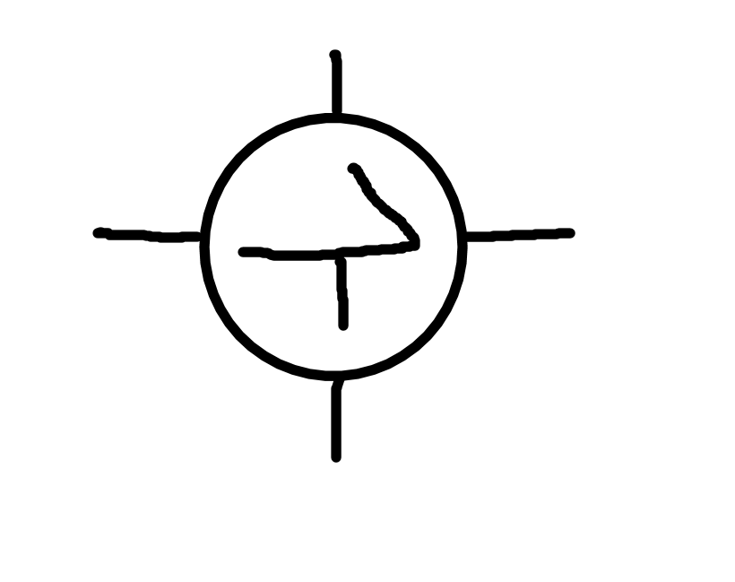

The Birth of the Headass

-translated from the book of sakkadian-

This is a long and important tale describing the original headasses. First there was Lindsey the founder of Sakkadian. There are multiple other prominent gods and figures, such as Laz. Laz was just a normal citizen until he became divine. Laz was hit in both of his eyes simultaneously by blessed rain and he saw the truth, his truth. The next day Laz saw Mr. loose and knew exactly what he needed to do. Laz looked up at Loose and proclaimed “you sir, are a headass”. That moment changed everything. Loose became a headass; however, he isn’t the only one. Laz looked up to the sky with his eyes finally able to see divinity and shouted “Lindsey you are quite the headass”. Then there were two. The story details three headasses but no-one knows the identity of the third. The only person who might know the identity of the final headass would be Laz himself; however, Laz refuses to say whom it may be. There are two parts to this tale and the second will begin now. When one of the three originals call someone else a headass that person then becomes a minor headass. There are no records of all minor headasses created by the three, but it is believed that loose never made any minor headasses. Because we do not know the third we are unaware as too which of the other two headasses has more minor headasses in their branch. Till this day Laz’s story is still told throughout the people of sakkadia in oral tradition and now it is being told through the kareble.

-lindsey 9/4/19 tales of sakkadia

The Great Sakkadian Serpent

There was once a great serpent that lived on Karelian mountain amd terrorized all who went there. The serpent was much stronger than other snakes for some unknown reason. Noone dared to try to slay the great snake and those who did were killed. The serpent remained on the mountain until a hero changed everything. Lindsey the Sakkad decided to visit the serpent, many of her followers told her not to do it; however, Lindsey the great was not easily discouraged. The great hero grabbed their jacket and headed to the dangerous Karelian mountain range. The mountain was cold and it was dark, but the great hero kept going. It was hours before our hero decided to take a rest near the top of the mountain. That’s when she saw it, a large red and white snake sat on the top of the mountain shivering. Lindsey soon realized that the great serpent wasn’t a serpent at all, It was a Dragon. Our fearless leader snuck up behind the dragon and slowly went around to the dragons head so she wouldn't startle it. The dragon roared and tried to attack the hero, Lindsey was too fast and dodged the attack. Lindsey moved so fast that when the dragon realized it hadn't killed her she had already tied it down. that’s when Our hero realized that the dragon wasn’t supposed to be slayed it was meant to be tamed. Lindsey the great took her jacket and put it on the dragon because he looked cold. She then took a peach snapple out of her pocket and let the Dragon drink it. The dragon realized that Lindsey the great was a friend and it calmed down. Lindsey pet the dragon and proclaimed “you shall be named Swimmy and you are now my friend”. She untied the dragon and they sat on the top of the mountain together and looked at the empty land below and then she decided that they would create a city as strong as Swimmy. She named that city Sakkadia. The dragon bowed and turned into a sword with a hilt that had a dragon pattern on it. From that point forward Lindsey’s sword skills and Swimmy the sword made sure that she never lost another fight. Lindsey the great took the sword and summoned Swimmy out of it. They flew down the mountain. This moment is very famous and there are many paintings of our hero flying on a great dragon with excellent style. Lindsey later bought the Dragon a jacket of his own and they matched.

-Tales of Sakkadia 10/8/19

The Karelist and the E-Girl

There are terrible creatures hiding in The Eastern Sakkadian plains, one species of these demons are E-Girls (Evil Girls) . The Eastern Sakkadian Plains are the home land of Barrax Obunga, one of the most dangerous individuals on this earth. Barrax Obunga is the Ceo of evil. The E-Girls hide in plain sight as thotty individuals. They are almost impossible to kill an extremely dangerous. Few individuals were strong enough to challenge the E-Girls, this tale is about one of those individuals. Martin of the Sementoes also known as Martin was and still is a prominent figure of karolism, and he is recognized in Sakkadia as a patron saint. His best known patron topic is gay, and he is often called the Patron Saint of homosexuality. Martin of Karolism was a brave soul and didn’t blink at the danger of thottery especially because he never took interest in their tricks of disguising themselves as thots. Martin was traveling to The River Stew when he was stopped by a girl dressed in a crop top and jean shorts. Martin immediately knew what she was, E-girls commonly dress like in such attire. The creature walked towards him and said she was lost and needed help in a shrill voice. Martin replied by saying “Not one more step”, the thot smiled and replied “I see you've figured me out,''she then pulled out a knife and her teeth became razor sharp. Martin shivered, it was a truly disturbing sight to behold. She ran at martin and he quickly hopped up into the air gracefully dodging her attack. He drew his weapon and said “Im warning you,” Martin laughed. The E-girl growled, “why are you so cheery, im going to kill you,” Martin disappears. “I see your running, I am ten times faster than you and when I catch you..” she was interrupted by Martin stopping and standing in front of her. “How are you going to catch me when you have no legs” said martin. “What are you saying, of course I have legs”. The E-girl looked down and to her surprise her legs were gone, “what have you done” she shrieked. Martin started to walk away, but she used her hands to walk and charged at him. Martin stopped and said “fine, have it your way”. Martin leaped up into the air and yelled “BEGONE THOT” then our hero sliced the foul creature in half. She melted away and turned into red stone with a sakkadian symbol on it. Martin picked up the stone and slung his sword over his shoulder as he walked off into the night. It is rumored that Martin still has the stone of the E-thot.

-Tales of Sakkadia